**Name:** Thomas Caetano

**Date:** 10-11-2021

**Course:** PYTHON FUNDAMENTALS – UW (IT FDN 110 B)

**INTRODUCTION**

This was by far the assignment in which I was able to overcome some of the biggest challenges so far as I don’t find python to be as logical as it is claimed to be. PROLOG and BASIC make more sense, but ok I chose python and it’s still great – thanks Guido.

Assignment V was challenging but easier to understand finally – FOR loops inside WHILEs are almost fourth nature (calling it second nature would be an exacerbation). Declaring empty variables and lists in the beginning of the programme is making more sense as these empty vars have to exist before they can be “filled” with data.

I now understand that FOR xxx IN xxx: loops are used to unpack data and spread it out – this was confusing in the beginning and this one is definitely second nature now – I am happy 😊 by understanding this.

**Assignment05.py**

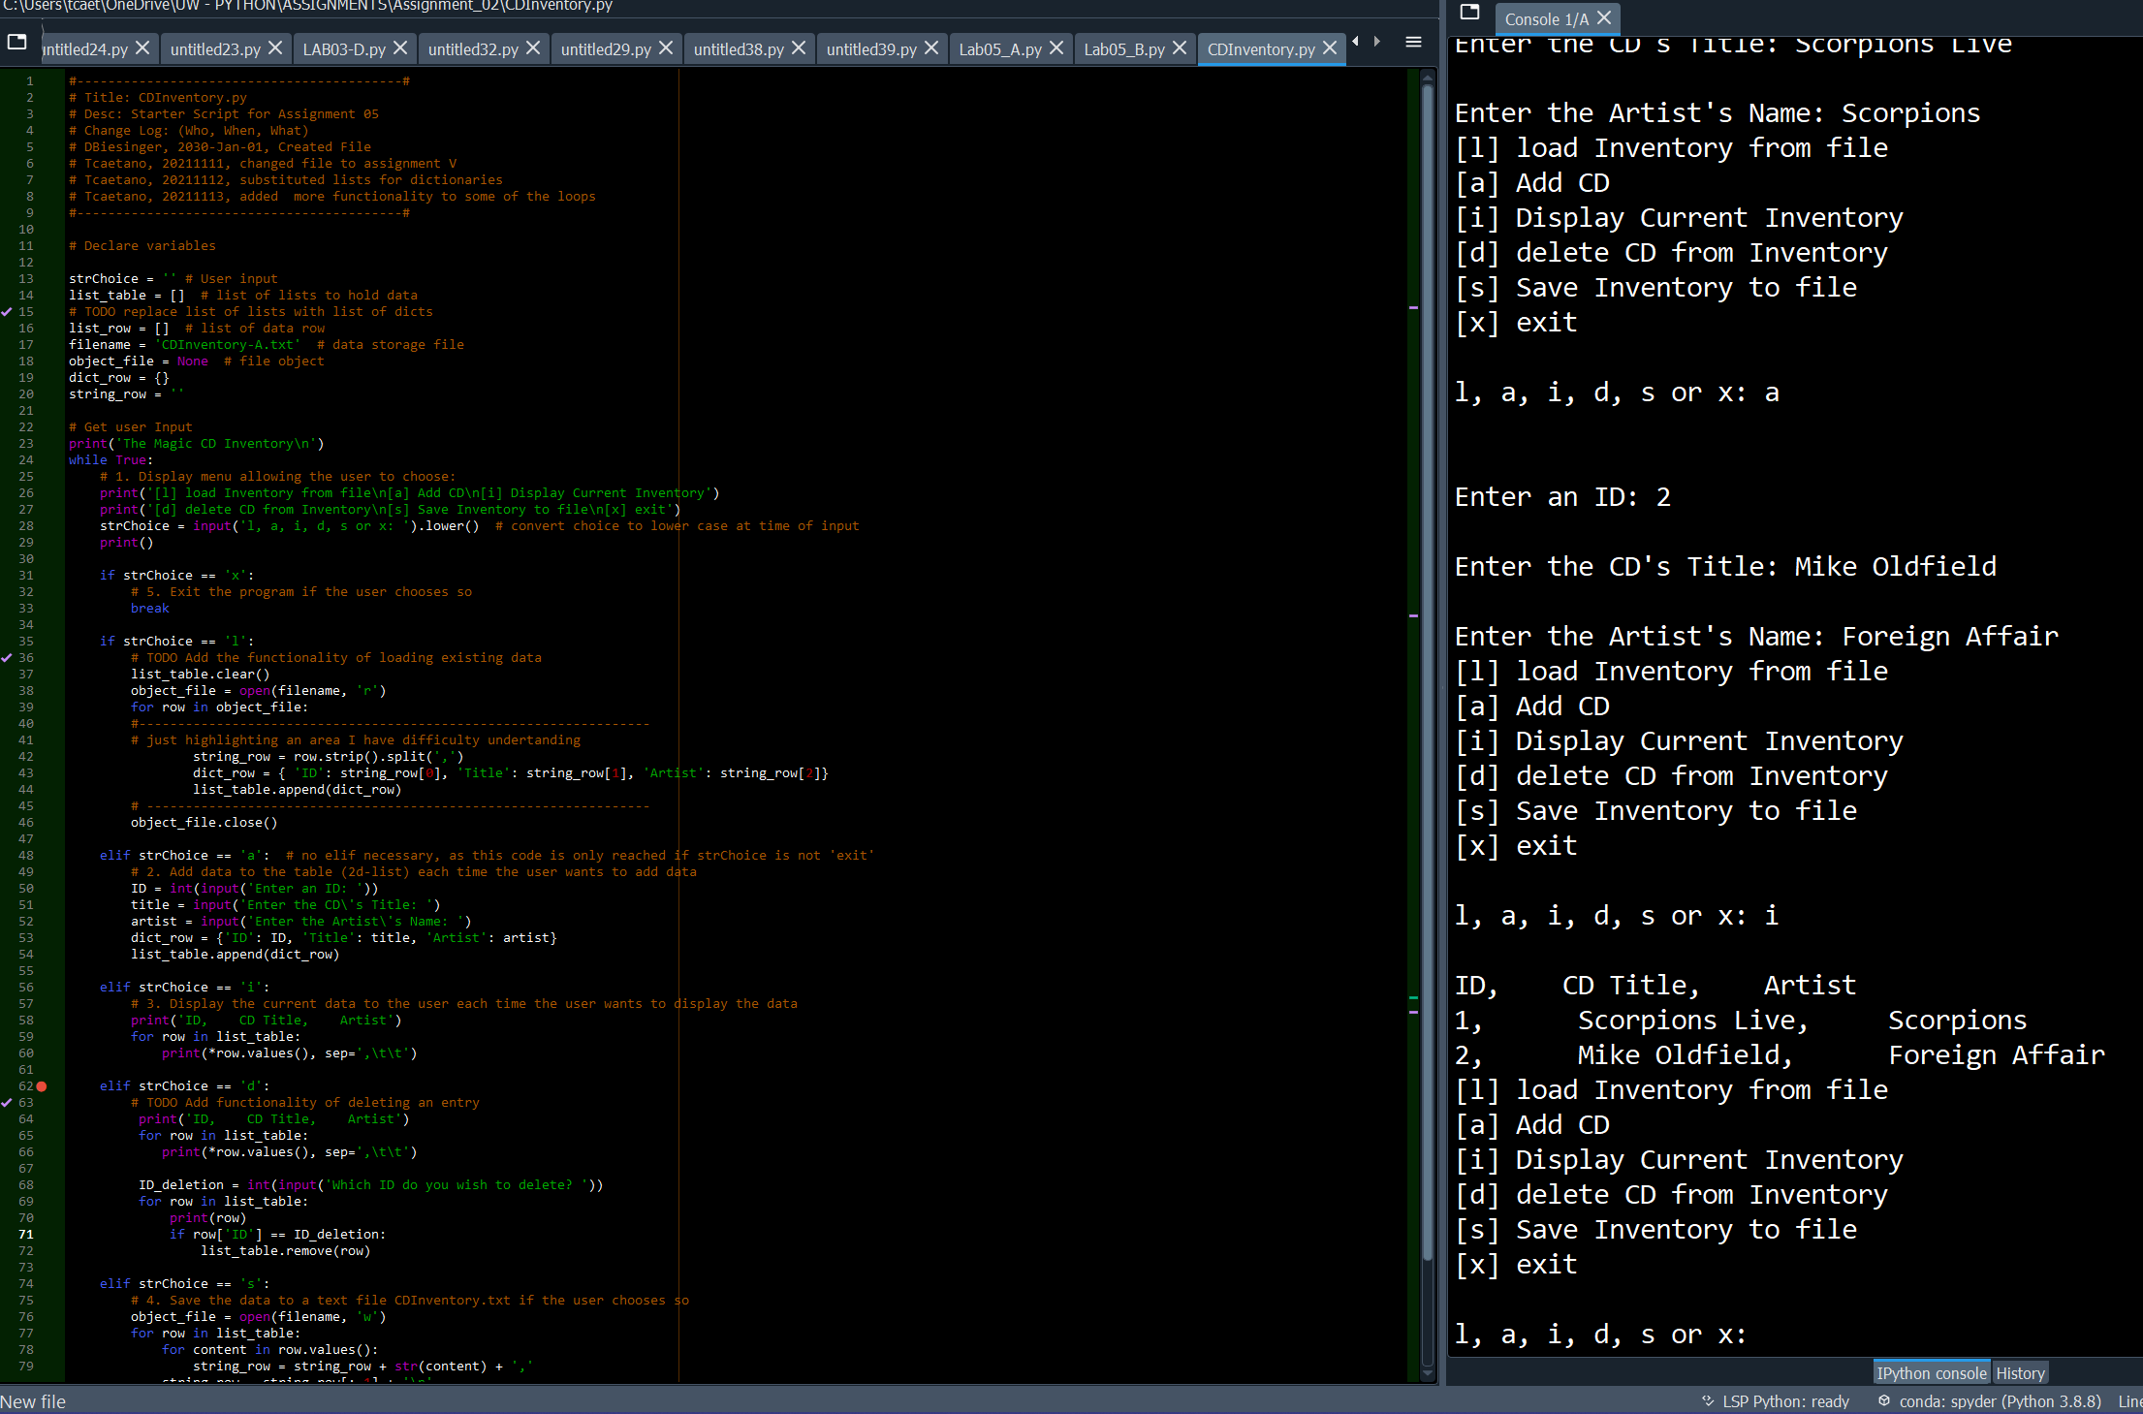

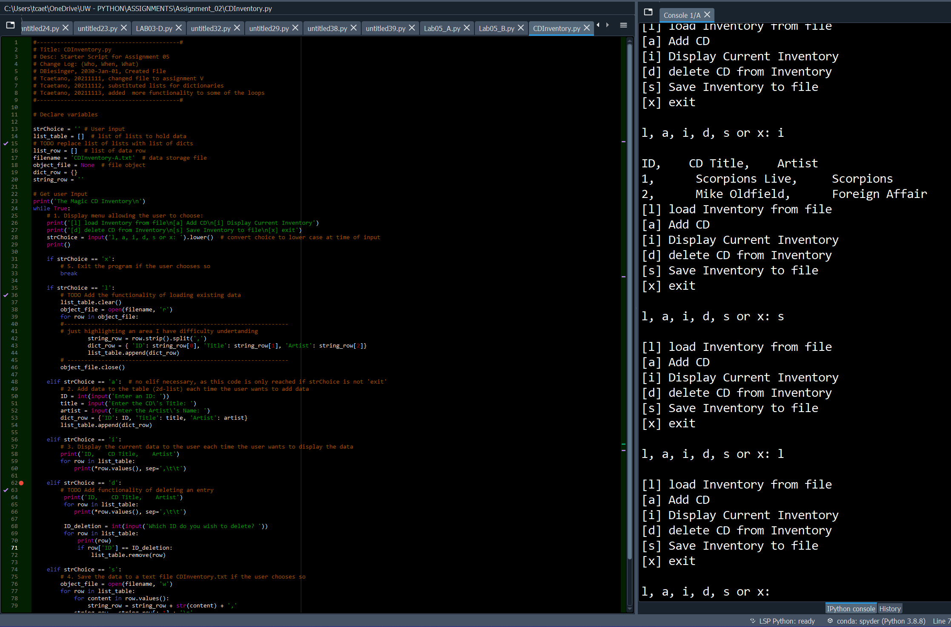

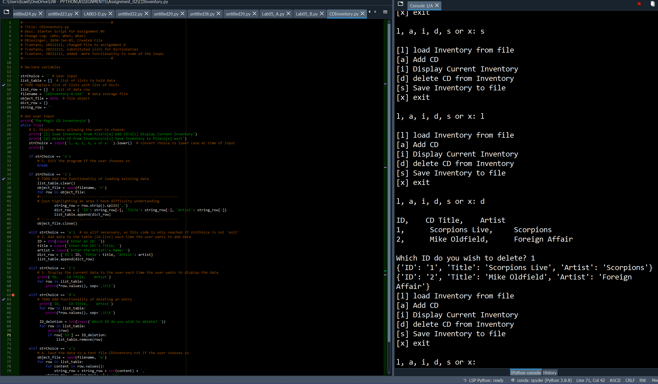

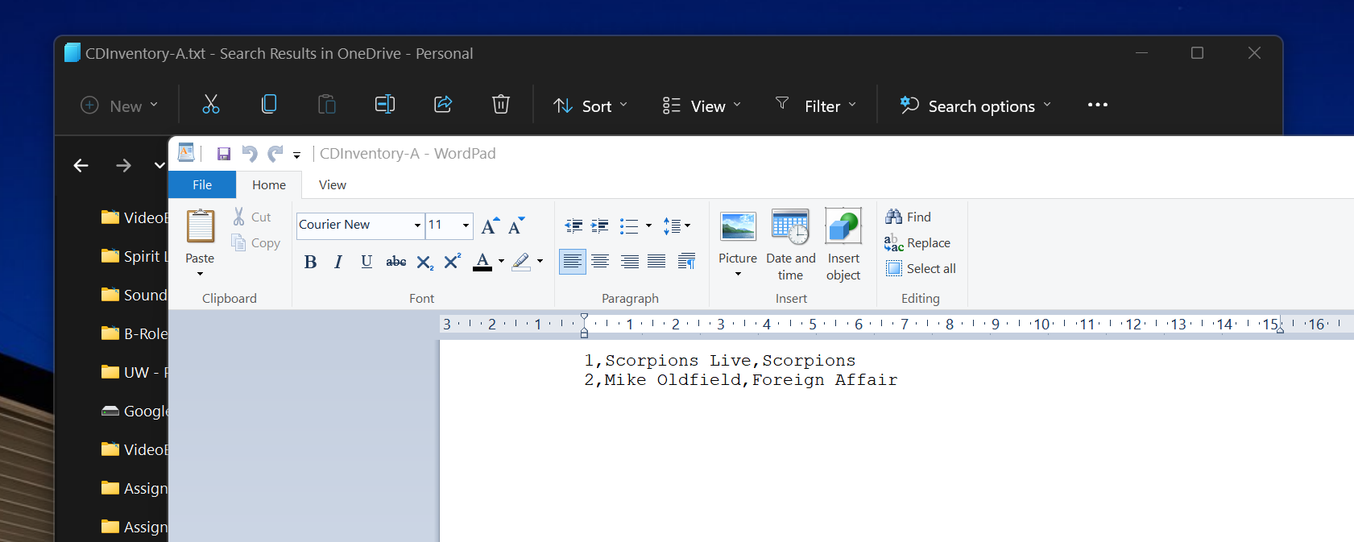

From the terminal:

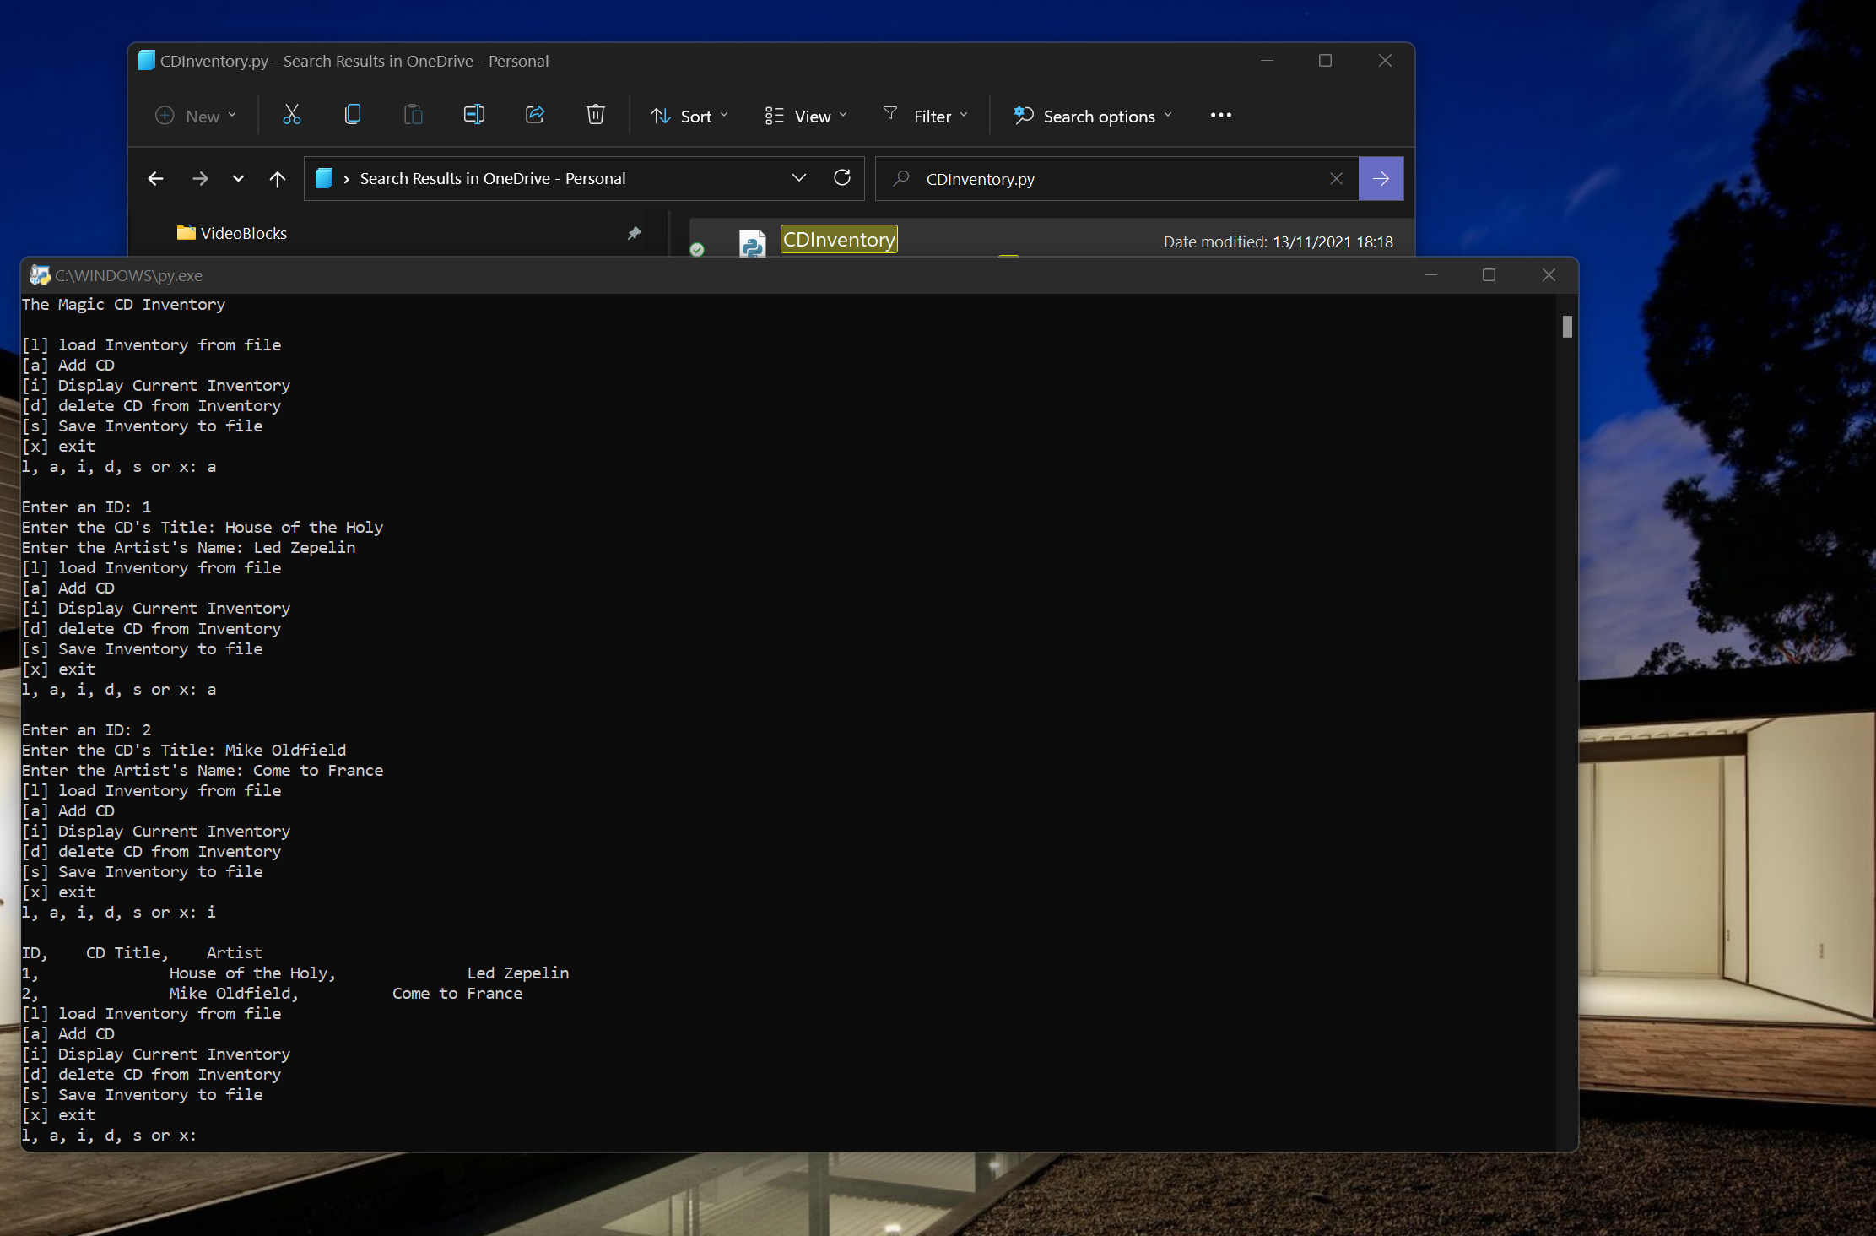

LAB 05-A: Working with Files and Lists  
In this Lab, you’ll be working with lists and files: Complete the starter code to read and write data from list to file.  
We will be re-visiting the CD Inventory application throughout this course. Either use below examples or two of your  
own to complete this Lab.

**Hint:** Use a 2D list to hold the data.  
1. Review the code and make some notes about what it is trying to accomplish.  
2. Save the starter script as Lab05_A.  
3. Add to the header  
4. Replace the TODOs with your solution for the task stated.  
5. Test your script and write down how the code works.

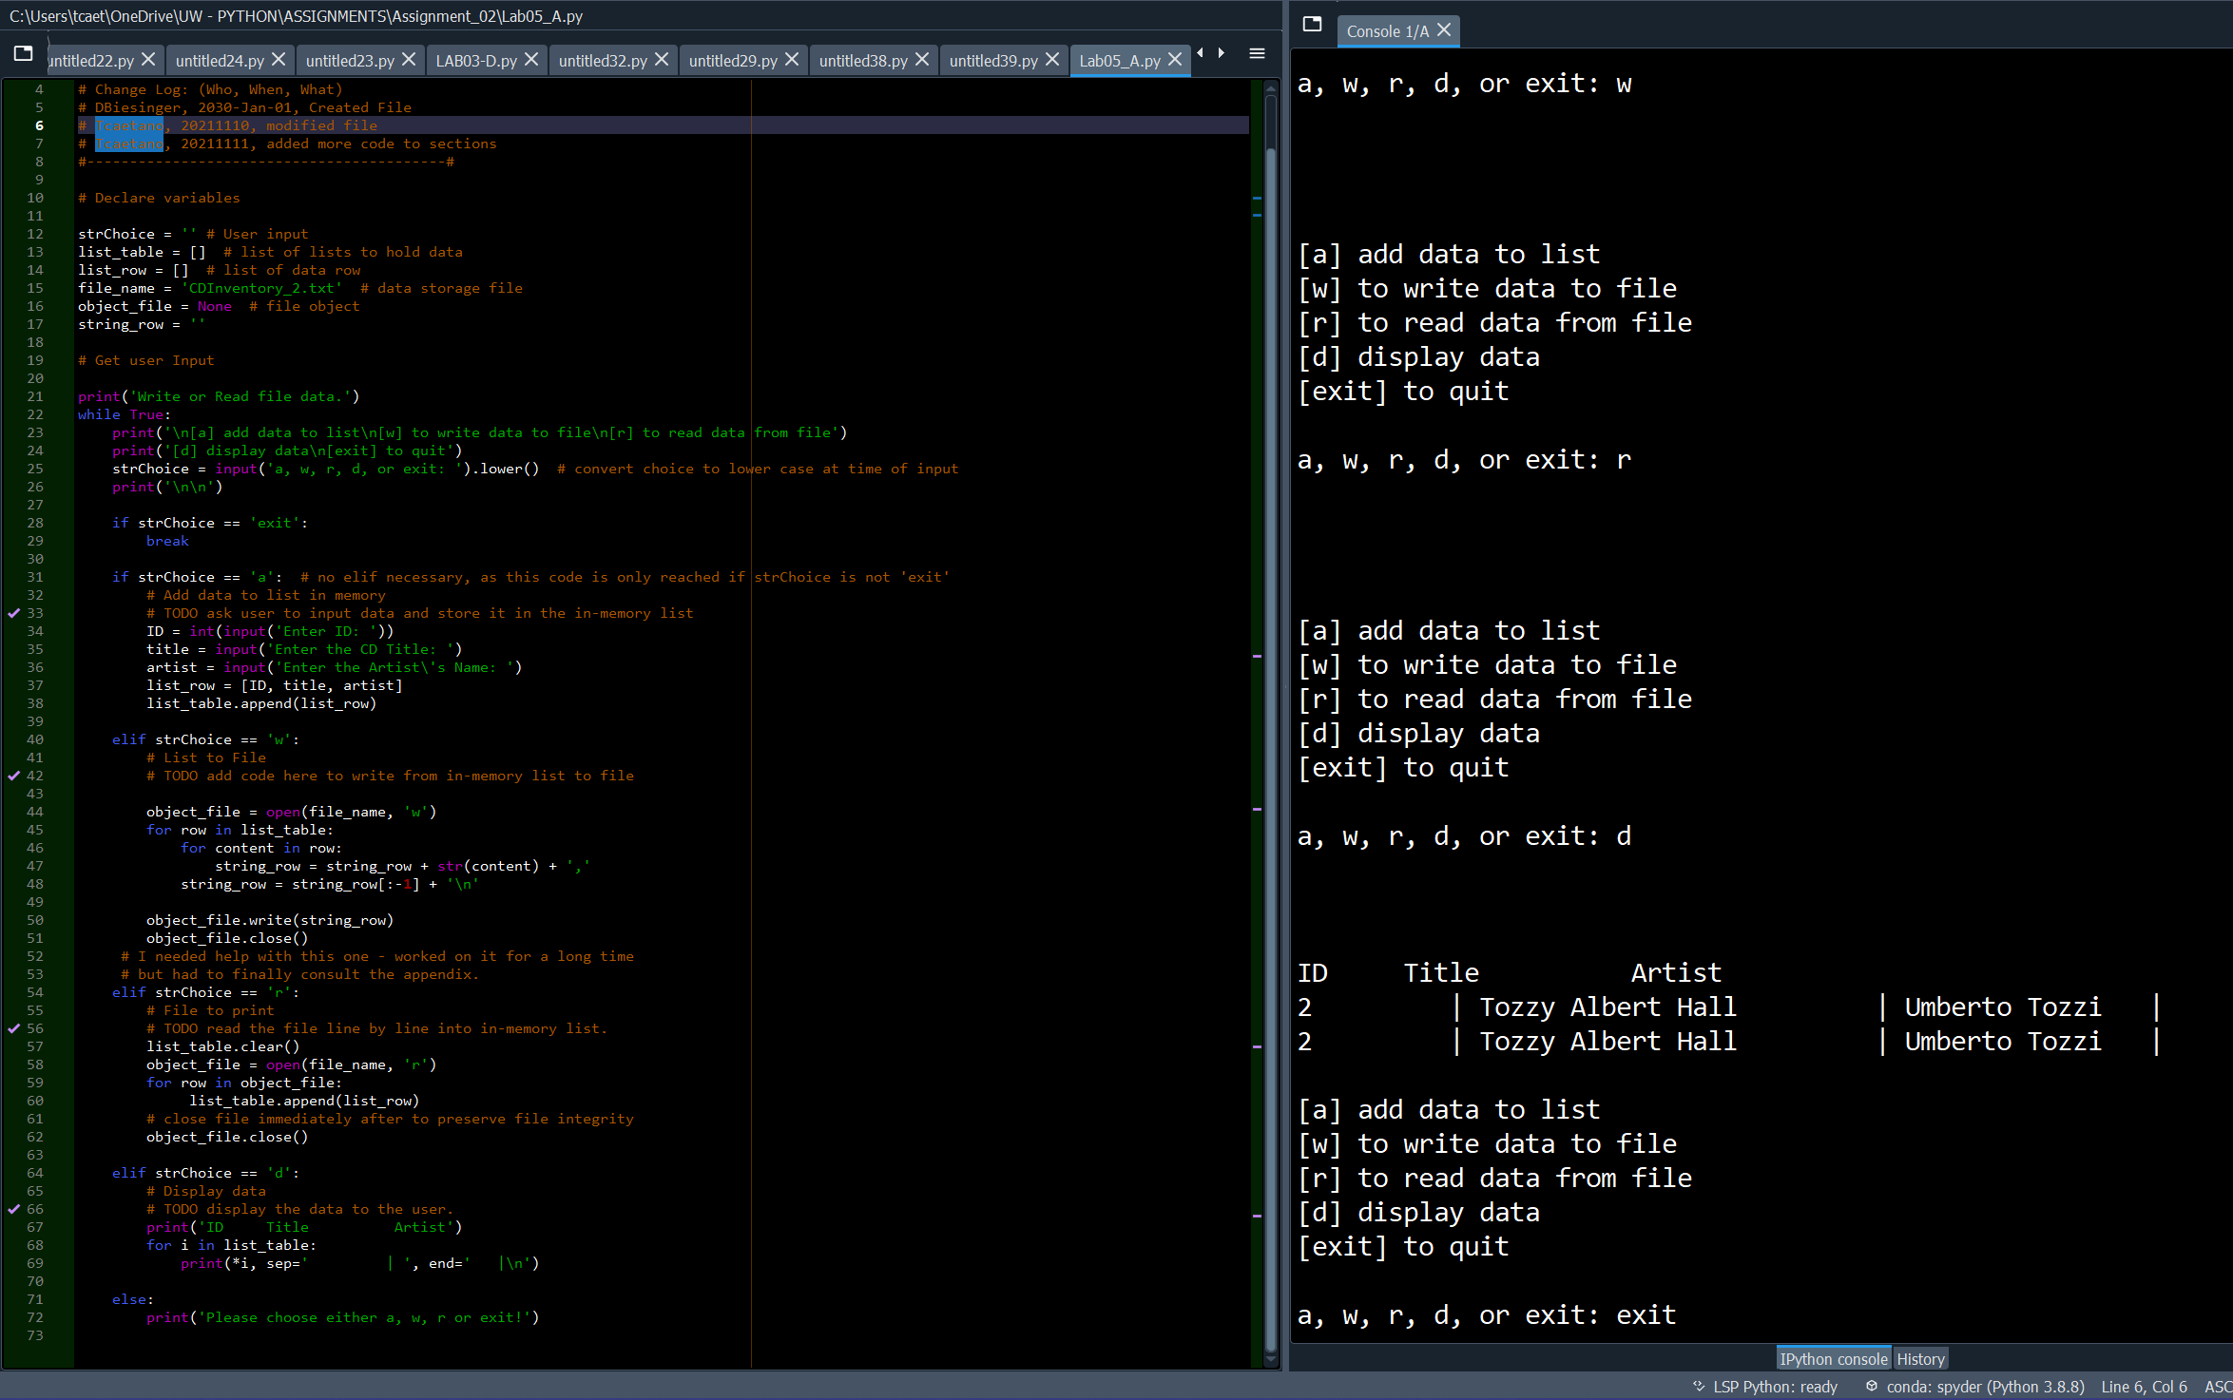

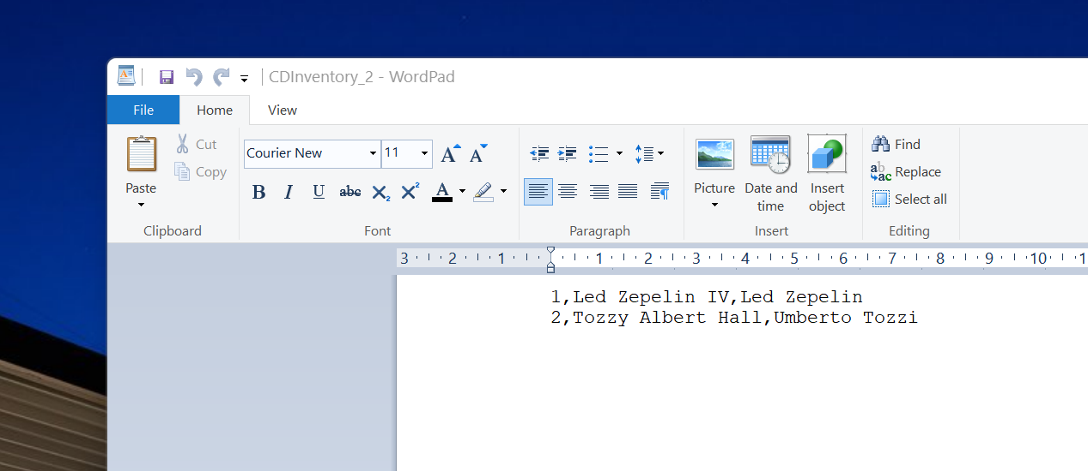

I worked on this without looking at the solution – for a few hours. I am slowly becoming more familiarised with how this code works. The major obstacle I had last time was how menu options work in the midst of a WHILE loop. The answer is of course that the input strings have to be inside the loop not the opposite. The IF and ELIF statements are now easier to understand – ELSEs do not necessarily have to exist after an IF or ELIF clause.

This code is straightforward: Variables are declared in the beginning, some with empty states, [ ], ‘ ‘. User input is accepted inside the WHILE loop and then the entered values are processed are assigned variables. IF clauses take in the options given by the user and then evaluate them. Each entry will trigger it’s own loop. Add data, save data, load data, exit, etc. The most challenging portion is the write data – the formatting is somewhat strange but I will get used to it. All else was fairly easy to comprehend after Herr Biesinger explained to me where the input() should be.

LAB 05-B  
In this Lab, modify the code from Lab 05-A to use dictionaries instead of lists for the rows. (refer to the Appendix for an  
example solution of LAB 05-A)

1. Make a copy of the LAB05-A solution.  
2. Replace the inner lists (for the rows) with a dictionary solution.  
3. Test the script and write down how the code works  
4. Have a look at this script’s output. Can you think of a way to improve it? Describe what should be done  
differently and how you would do it.

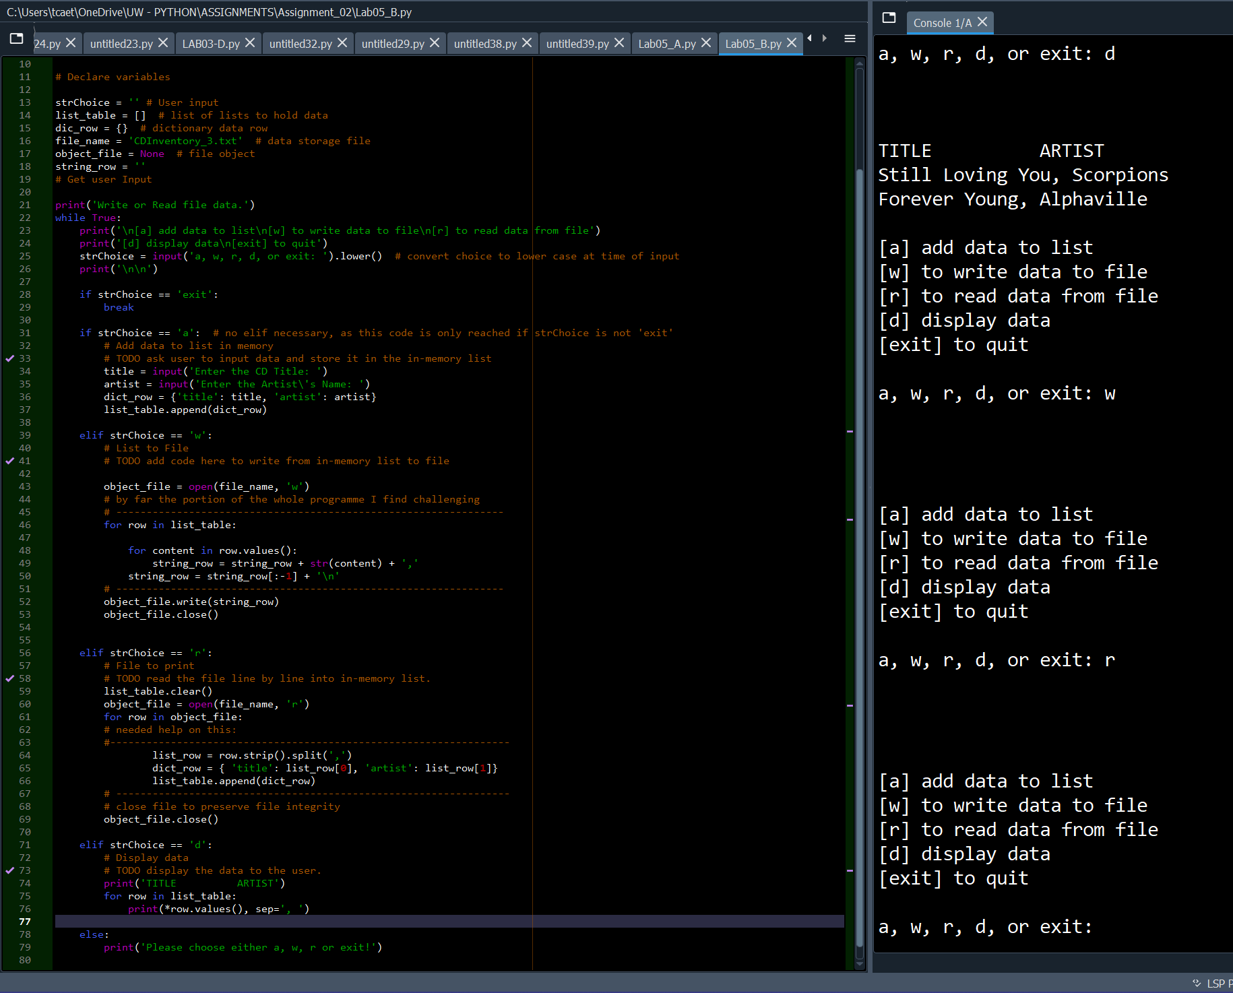

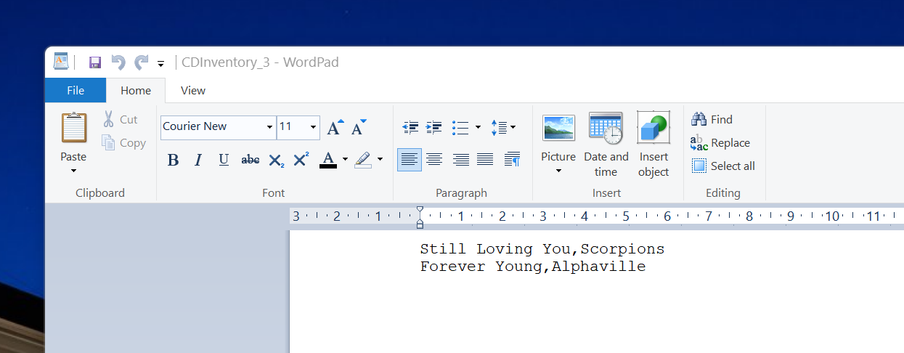

This lab was far more easier to understand after having the experience of working through the first lab.

It was important for me to understand both labs without assistance so I worked on them until I could not come to a resolution of one of its parts – the write portion, thus I consulted the solution at the end of the study .pdf, to get some help. I tried several venues to solve this issue but ultimately I needed more help – I don’t feel guilty about looking at the solution because I worked my rear end off to write this code without any help from solution code.